Name of the Department: Administrative Office
Item No.: 1 Quantity Req. : 02
Name of the Item: Split Air Conditioner
Estimated unit Cost Rs. 55,000/- Estimated Total Cost Rs.1,10,000/-
Specifications:
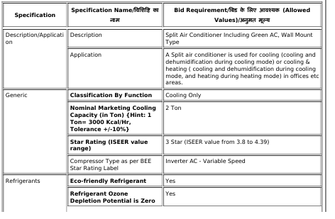
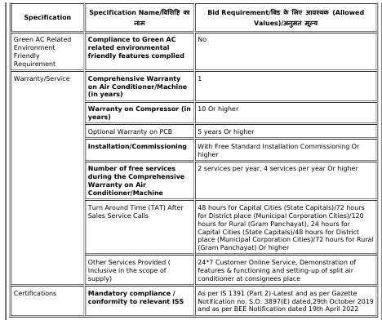

Note: Additional Specification is as per bid documents
Name of the consignee department(s):
Sr.No. | Department | Quantity required
1 | Administrative Offices | 02
2
Total |  | 02

Expert Committee members of the department:
Sr.No. | Name | Designation | Department | Signature
1 | Dr. V R Patel | Professor | Electrical
2 | Prof Anjana Prajapati | Asso. Professor | Mechanical
3 | Prof M Y Patil | Asso. Professor & Store Officer | Mechanical
5 | Prof N H Pancholi | Assi. Professor | Mechanical
6 | Prof K K Pansal | Assi. Professor | Mechanical
4 | Prof N D Rabara | Assi. Professor | Electrical
7 | Prof Bhavesh Parmar | Assi. Professor | Biomedical

HOD, Sign & Stamp

